##### MODULE HANDBOOK

**Data Science Professional Practice 1: Organisational Structures and Objectives within Data Science**

**Data Science Professional Practice 1: Organisational Structures and Objectives within Data Science**

## Introduction

The success of data science within an organisation depends not only upon a good understanding of the technical skills involved in data science and machine learning, but also on the ability of the data scientist to **identify** projects that offer **business value**. They must then be able to **promote** any data science projects to stakeholders, **plan** a project **and negotiate** with colleagues to ensure its successful delivery. This module will provide you with the business knowledge and awareness to achieve these goals effectively.

##### The aim of the module

The primary aim of this module is to provide you with the core knowledge and understanding needed to deliver data science projects in the context of your organisation. It will cover underpinning concepts for many of the “knowledge, skills and behaviours” associated with the Level 7 Research Scientist Apprenticeship standard.

**The module will provide teaching on the following topics:**

* **Organisational context for data science**
* **Leadership, teamwork and collaboration**
* **Effective communication, negotiation & influencing**
* **Project management**
* **Problem solving and project planning**
* **Professional conduct, ethics, regulations and personal responsibility**
* **Development of self and others**

**INTENDED LEARNING OUTCOMES (ILOs**) (see assessment section below for how ILOs will be assessed)

On successful completion of this module **you should be familiar with these areas of knowledge specified in the Research Scientist Apprenticeship Standard:**

|  |  |
| --- | --- |
| **Module Specific Skills and Knowledge:** | |
| **1** | **Describes the employer’s organisational structure and where their own role fits. (K2)** |
| **2** | **Describes where their role has contributed to the successful achievement of an organisational objective, and provides examples of when they have communicated effectively with a wide range of senior leaders across different departments (K2 & B1)** |
| **3** | **Describes the importance of continuing professional development and how to maintain their own specialist knowledge in an ever evolving environment. (K8)** |
| **Discipline Specific Skills and Knowledge:** | |
| **4** | **Describes the importance of CPD backed up by planning and/or demonstrating intent, including relevant accreditations /licenses applicable to role. (B7)** |
| **Personal and Key Transferable / Employment Skills and Knowledge:** | |
| **5** | **Explain how you utilised interpersonal skills, communication and assertiveness to persuade, motivate and influence. (K8 & S8)** |
| **6** | **Describe examples of when they have provided leadership within a team of multi discipline specialists at different levels across the organisation, ensuring a shared vision and commitment to success. (K2)** |
| **7** | **Explain how they have utilised interpersonal skills, communication and assertiveness to persuade, motivate and influence. (S4)** |

|  |
| --- |
|  |

|  |  |
| --- | --- |
|  |  |
|  |  |
|  |  |
|  |  |
| In addition to its academic aims as part of MSc Data Science (Professional), this module has specific aims as part of the Level 7 Research Scientist Apprenticeship.  The full list of **Knowledge, Skills and Behaviours** that must be demonstrated to complete the Apprenticeship can be found here: <https://www.instituteforapprenticeships.org/apprenticeship-standards/research-scientist-v1-0> .  This module will deliver content associated with the **Knowledge, Skills and Behaviours** set out below:   |  | | --- | | Knowledge (K), Skill (S) or Behaviour (B) | | **K2**: Management, leadership and effective communication. Organisation objectives and where their role contributes to the success achievement of these objectives. How to communicate effectively with a wide range of senior leaders across different departments, up and down the supply chain, within their own team. Advanced mixed media communication, such as presentations, report writing (technical and non-technical) negotiation and influencing. Leadership within a team of multi discipline specialists at different levels across the organisation, ensuring a shared vision and commitment to success. Effective project management as used in their employer’s environment with regard to quality, cost and time. The employer’s organisational structure and where their own role fits. | | **K8**: Development of self and others: The importance of continuing professional development and how to maintain their own specialist knowledge in an ever evolving environment. How to effectively coach and mentor colleagues, peers or team members to address identified skills gaps, using appropriate methods. How to upskill non-technical colleagues to enable them to complete their own role as needed. | | **S4**: Communication Skills: Write extended reports and critique others' work across a range of documentation, e.g. protocols, consent forms and scientific reports. Deliver oral presentations and answer questions about their work and/or the work of their team. Utilise interpersonal skills, communication and assertiveness to persuade, motivate and influence. Discuss work constructively and objectively with colleagues, customers and others; respond respectfully to and acknowledge the value of alternate views and hypothesis. | | **S8**: developing others: Apply a range of coaching and mentoring techniques with colleague’s peers and team members, selecting the correct method to suit the situation and the person being coached / mentored. | | **B1**: Team Working: Collaboration, influence, and respect for others. | | **B7**: Continuing Professional Development (CPD): Accountability of own and others development needs, undertaking CPD. Curiosity of science and proactively develops knowledge to ensure that scientific and business decisions are based on strong science. | | | | |

**Learning and teaching**

The module is delivered through an online blended learning approach and guided student independent study.

You can access the Module Exeter Learning Environment (ELE) 24/7.

The **summative assessment is two assignments** which can be used both within your portfolio of evidence for your End Point Assessment (EPA), as well as being used as the combined 100% academic assessment for this module.

There are different types of content that can be found on ELE, and the Module has been broken down into bite sized learning and interaction for your ease of access.

There are ‘**Reflective moment’** focussed questions which help you relate the content to your own organisation and role.

**Required reading**:

* The Level 7 Research Scientist Apprenticeship standard: <https://www.instituteforapprenticeships.org/apprenticeship-standards/research-scientist/#K1>
* All Web-based and electronic resources provided for you on dedicated ELE site:

**Key learning elements**

* Films and content on ELE and online, articles, blogs etc. will be found throughout the course readings on the ELE Module site. They are there to provoke thinking, and do use them to help you capture outputs to take back into your coursework and portfolio.
* Offline learning, selected articles, books and materials will be suggested at times, and links on ELE will take you to these materials or show you where to get them.

These will not be required reading but additional to the core content.

**Module Assignments Information**

This module is assessed by 2 assignments (weighting 40% and 60%)

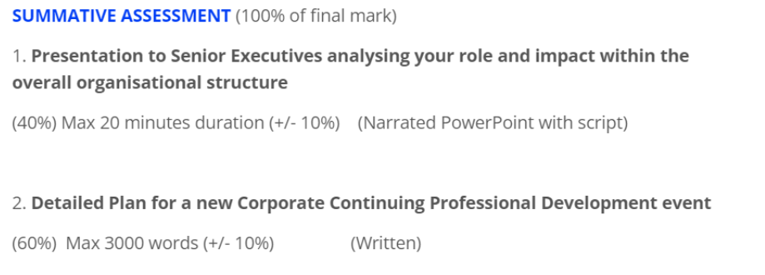

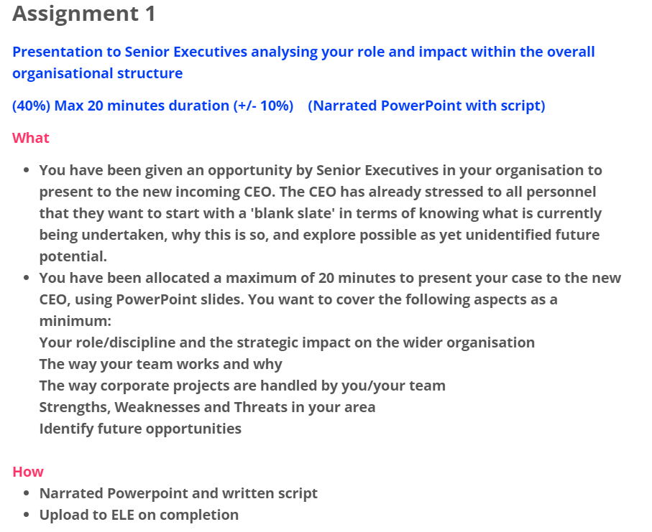

**Information and advice re Assignment 1**

**ILOs covered: 1,2,6,7**

**There is no limit to the number of slides you use but the time limit for your narrated presentation is 20 minutes (+/- 10%). So think carefully about how many slides you use and need to speak to. It is best to be clear, focussed and visually impactful.**

**Throughout your presentation/script include reference to appropriate and relevant Knowledge from the Research Scientist Standard.**

**As you write annotate using the comment function where you reference any of the knowledge KSBs in your work.**

**Doing this will make it much easier for you to identify evidence from your assignment for your e-portfolio in OneFile later.**

**Structure of the presentation**

**Think about sharing your personal knowledge, experience/view of elements of the following:**

|  |  |
| --- | --- |
| **1** | **Describes the employer’s organisational structure and where their own role fits. (K2)** |
| **2** | **Describes where their role has contributed to the successful achievement of an organisational objective, and provides examples of when they have communicated effectively with a wide range of senior leaders across different departments (K2 & B1)** |
| **6** | **Describe examples of when they have provided leadership within a team of multi discipline specialists at different levels across the organisation, ensuring a shared vision and commitment to success. (K2)** |
| **7** | **Explain how they have utilised interpersonal skills, communication and assertiveness to persuade, motivate and influence. (S4)** |

**This presentation should demonstrate knowledge gleaned from the module and provide a potential to be able to demonstrate the knowledge, from the Research Scientist standard in the workplace.**

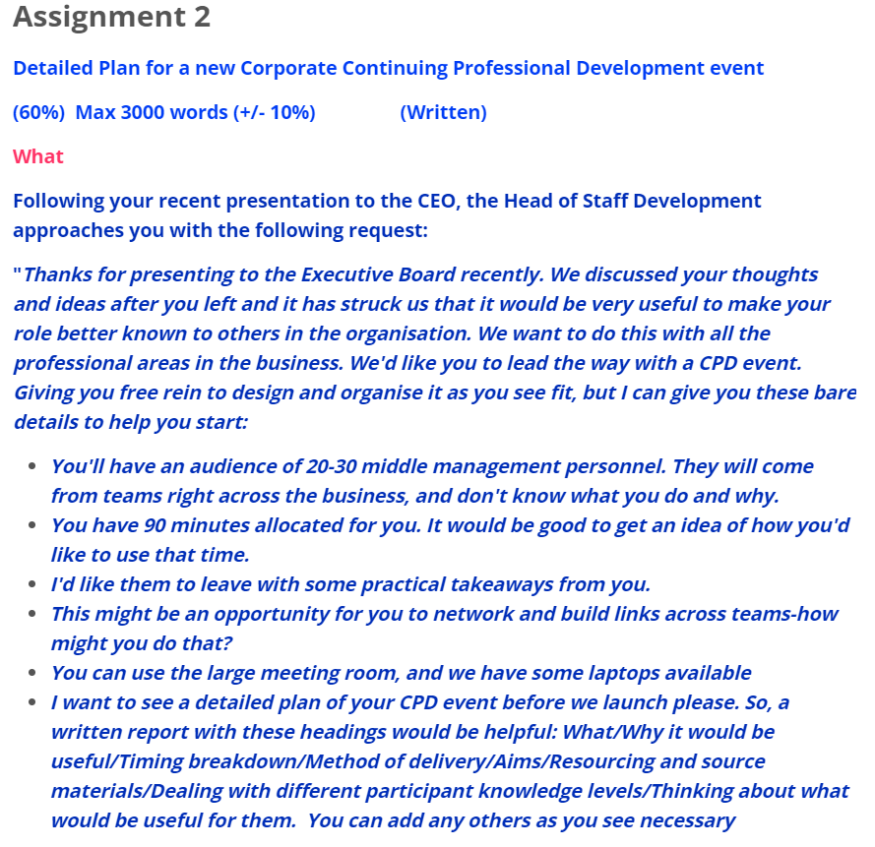

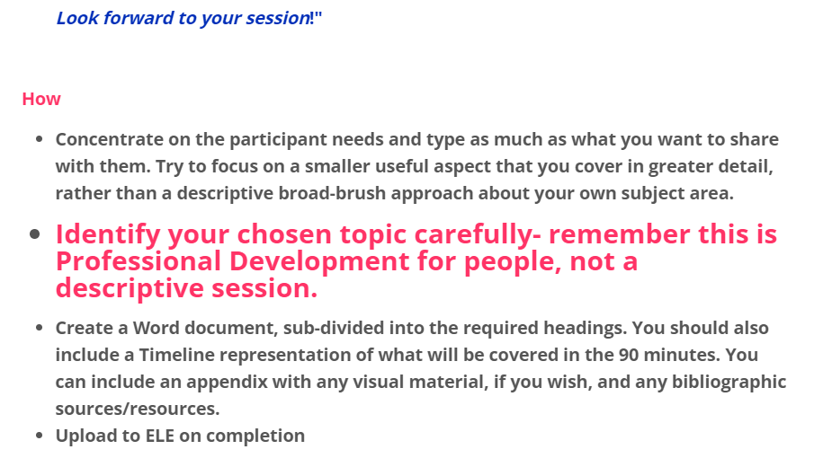

**Information and advice re Assignment 2**

**ILOs covered: 3,4,5**

**Word limit is 3000 words (+/- 10%)**

**Throughout your script include reference to appropriate and relevant Knowledge from the Research Scientist Standard.**

**As you write annotate using the comment function where you reference any of the knowledge KSBs in your work.**

**Doing this will make it much easier for you to identify evidence from your assignment for your e-portfolio in OneFile later.**

**Structure of the CPD Plan report**

**Think about sharing your personal knowledge, experience/view of elements of the following:**

|  |  |
| --- | --- |
| **3** | **Describes the importance of continuing professional development and how to maintain their own specialist knowledge in an ever evolving environment. (K8)** |
| **4** | **Describes the importance of CPD backed up by planning and/or demonstrating intent, including relevant accreditations /licenses applicable to role. (B7)** |
| **5** | **Explain how you utilise interpersonal skills, communication and assertiveness to persuade, motivate and influence. (K8 & S8)** |

**Content required:**

* **Introduction**
* **Why the topic would appeal, and how you would persuade participants about the appeal and usefulness of the topic given they come from other areas of your organisation.**
* **CPD workshop: aims, objectives, utility to organisation and participants (link to known imperatives in your own organisation and how this development opportunity would support those)**
* **Delivery plan: who, what, timings, resources, details of content (examples), handouts, positioning/moving people in the room etc**
* **Style of delivery: directive, group work, individual, online or offline activities, considerations for different ways people learn, EDI considerations, (dyslexia/dyspraxia etc) etc**
* **The main takeaway aim for participants and impact for them, their wider teams and the organisation as a whole.**
* **How you would organise feedback, and consideration of post CPD event reflection for yourself**

**You can include any visual examples of material, formal references etc you might devise, either in the body text or in a brief appendix (see word count advice below).**

**You may include additional content that will be pertinent to you and your own organisation.**

**This report should demonstrate knowledge gleaned from the module and provide a potential to be able to demonstrate the knowledge, from the Research Scientist standard in the workplace.**

**Marking Rubric for Assignment 1**

|  |  |  |  |  |  |
| --- | --- | --- | --- | --- | --- |
| **Mark** | **(Fail/Non-Condonable Fail)** | **(Pass)** | **(Merit)** | **(Distinction)** | **Weighting** |
| **Marking Criteria** | **<50** | **50-59** | **60-69** | **>70** | **% of total mark** |
| **Knowledge and understanding of the subject area Analysis and Reflection**  Demonstration of logical analysis and critical reflection. | No critical analysis or reflection; poor use of models, frameworks and module content. Does not provide evidence for a strategy. | Weak critical analysis and reflection with minimal reference to the theories and concepts presented in the course materials. Largely descriptive and/or operational rather than analytical or strategic. | Good critical analysis and reflection on the theories, concepts and strategic models presented in the course materials. . Further supported with convincing evidence. | Excellent arguments, strong analysis and critical reflection using the theories, concepts and strategic models. | 40% |
| **Structure**  1) clear structure, and attention to grammar and spelling.  2) use of recommended reading and other supporting evidence.  3) correct academic referencing. | Poor structure and formatting. Rationale for the presentation is unclear. Consistent errors with language and grammar making the presentation hard to follow or understand. No references used. The presentation does not address the brief. | Reasonable structure; but fluency could be improved. Some errors or inconsistencies in grammar, vocabulary and referencing. Limited use of module material, or poorly chosen sources. The presentation only partially addresses the brief. | Good, evenly balanced structure throughout with logical flow and transitions. Presentation is rational, easy to follow and addresses the brief. Few instances of formatting or referencing errors. Evidence of own thought and wider reading integrated appropriately into the deck. | Succinct structure, well-formatted and designed presentation that clearly addresses the brief in full. Only minor errors in language, grammar or referencing. Strong evidence of further thought supported by a range of quality sources used judiciously to support relevant analysis, evaluation and recommendations | 20% |
| **Coverage of Core Themes:** **Describes the employer’s organisational structure and where their own role fits. (K2)**  **Describes where their role has contributed to the successful achievement of an organisational objective, and provides examples of when they have communicated effectively with a wide range of senior leaders across different departments (K2 & B1)**  **Describe examples of when they have provided leadership within a team of multi discipline specialists at different levels across the organisation, ensuring a shared vision and commitment to success. (K2)**  **Explain how they have utilised interpersonal skills, communication and assertiveness to persuade, motivate and influence. (S4)** | Little or no reference to core themes | Coverage of major themes but with little critical insight | Good coverage and some evidence of critical insight. Some development of independent ideas around these themes | Excellent coverage and critical insight plus clear evidence of independent thinking and development of new ideas in the field | 40% |
|  |  |  |  |  | **Total 100%** |

|  |  |  |  |  |  |
| --- | --- | --- | --- | --- | --- |
| **Mark** | **(Fail/Non-Condonable Fail)** | **(Pass)** | **(Merit)** | **(Distinction)** | **Weighting** |
| **Marking Criteria** | **<50** | **50-59** | **60-69** | **>70** | **% of total mark** |
| **Knowledge and understanding of the subject area Analysis and Reflection**  Demonstration of logical analysis and critical reflection. | No critical analysis or reflection; poor use of models, frameworks and module content. Does not provide evidence for a strategy. CPD plan would not be implementable without major modification | Weak critical analysis and reflection with minimal reference to the theories and concepts presented in the course materials. Largely descriptive and/or operational rather than analytical or strategic. CPD plan would be implementable with significant modification | Good critical analysis and reflection on the theories, concepts and strategic models presented in the course materials. . Further supported with convincing evidence. CPD plan would be implementable with some modification | Excellent arguments, strong analysis and critical reflection using the theories, concepts and strategic models. CPD plan would be implementable without significant modification. | 40% |
| **Structure**  1) clear structure, and attention to grammar and spelling.  2) use of recommended reading and other supporting evidence.  3) correct academic referencing. | Poor structure and formatting. Rationale for the presentation is unclear. Consistent errors with language and grammar making the presentation hard to follow or understand. No references used. The presentation does not address the brief. | Reasonable structure; but fluency could be improved. Some errors or inconsistencies in grammar, vocabulary and referencing. Limited use of module material, or poorly chosen sources. The presentation only partially addresses the brief. | Good, evenly balanced structure throughout with logical flow and transitions. Presentation is rational, easy to follow and addresses the brief. Few instances of formatting or referencing errors. Evidence of own research and wider reading integrated appropriately into the deck. | Succinct structure, well-formatted and designed presentation that addresses the brief in full. Only minor errors in language, grammar or referencing. Strong evidence of further research supported by a range of quality sources used judiciously to support relevant analysis, evaluation and recommendations | 20% |
| **Coverage of Core Themes: Describes the importance of continuing professional development and how to maintain their own specialist knowledge in an ever evolving environment. (K8)**  **Describes the importance of CPD backed up by planning and/or demonstrating intent, including relevant accreditations /licenses applicable to role. (B7)**  **Explain how you utilise interpersonal skills, communication and assertiveness to persuade, motivate and influence. (K8 & S8)** | Little or no reference to core themes | Coverage of major themes but with little critical insight | Good coverage and some evidence of critical insight. Some development of independent ideas around these themes | Excellent coverage and critical insight plus evidence of independent thinking and development of new ideas in the field | 40% |
|  |  |  |  |  | **Total 100%** |

**Marking Rubric for Assignment 2**

**Submission Guidelines**

Please submit your assignment(s) electronically **only** through the assignment submission link on the Exeter Learning Environment (ELE) module webpage. Do not submit any paper copies.

All submissions when uploaded must include an **Assignment Cover Sheet**. These are made available on the **ELE module page in the Assignment Submission tab**.

You should include the cover sheet as the first page, or first slide, of each of your assignments.

The following information must be included on the Assignment Cover Sheet:

**Module code:**

**Module name:**

**Candidate number:** e.g., 011633 (on every page)

**Word count:** e.g., 3,000 words

**ILP details:** any details of your ILP if this applies

***You should not include your student number (9 digit number beginning with 6) or your name anywhere on your assignments.***

**Late Submission of Assignments**

You must submit your assignment(s) by the deadline(s) specified. If you fail to submit on time and do not have an agreed extension the following penalties apply automatically:

* up to one hour late a 5% reduction in the final grade is applied.
* up to two weeks late the assignment is capped mark at 50%.
* later than two weeks and the assignment will receive a mark of zero.

Genuine mitigating circumstances should be supported by a Medical Certificate from your doctor in the case of illness. In all circumstances we will require formal evidence.

**Referencing**

You must provide a list of the articles and texts you have referred to. You should use the APA system of referencing.

**Cheating and Plagiarism**

Plagiarism can lead to exclusion from the module and is taken extremely seriously. “The University treats very seriously any case of a student attempting to seek unfair academic advantage through plagiarism or cheating”. Extract from Plagiarism and Cheating issued by the Academic Secretary, August 1996. For further guidance on Academic Honesty see the following web link: <https://vle.exeter.ac.uk/course/view.php?id=3044>

**Word counts**

You are required to meet the specified word count as detailed above. There is a permitted margin of +/- 10% on the specified work count. For example, for a 1,500 word limit the permitted range is between 1,350 and 1,650. You must specify the word count on the Assignment Cover Sheet.

Regular checks will be made to ensure that this is correct. Please refer to the list below on content included in the word count.

The following content **is not included in** a final word count:

* Reference list
* Bibliography
* Appendices
* Assignment Cover Sheet (refer to detail above)

The following content **is included** in a final word count:

* Title
* Contents page
* Abstract
* Executive summary
* Main body of text
* Words used in tables, graphs and other forms of data presentation (including titles of figures) in body text
* In text quotations
* Footnotes
* Section headings/subtitles